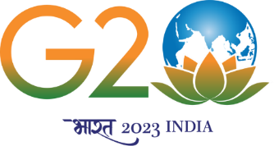
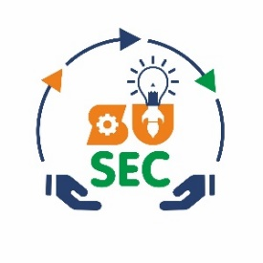
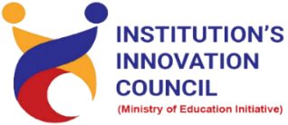
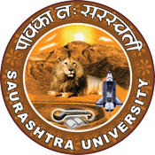

Intellectual Property
"Worth More Than Gold"
12th August 2023
At
Seminar Hall, ICAI Bhavan
Rajkot
Contents
Saurashtra University – IIC 2
Event Schedule 2
Event Registration Link 2
Brief about Event 3
Key Points 4
Outcome 4
About the Speaker/Chief Guest 4
Connect Us: 6

Saurashtra University – IIC
The university is dedicated to instruction, research, and extending knowledge to the public (public service). Ministry of Education (MoE), Govt. of India has established ‘MoE’s Innovation Cell (MIC)’ to systematically foster the culture of Innovation among all Higher Education Institutions (HEIs). The primary mandate of MIC is to encourage, inspire and nurture young students by supporting them to work with new ideas and transform them into prototypes while they are informative years. Saurashtra University is one the Organization that have constituted the IIC to foster the vision of MoE and be a part for the promotion and development of innovation ecosystem.

Event Schedule

Event Registration Link

bit.ly/SUSEC-ICAI

Brief about Event
SU Start-up and Entrepreneurship Council, in collaboration with ICAI Rajkot, organized an awareness talk on " Intellectual Property: Worth More Than Gold” on 12th August, 2023. The event was held at the mini auditorium at ICAI Bhavan, Rajkot. The event was a valuable opportunity for entrepreneurs, startups, and professionals to gain a comprehensive understanding of these crucial aspects of business law.
Basics of IPR and Patent Prosecution in India by Mr. Parth Sejpal: Mr. Parth Sejpal, a prominent figure in the startup ecosystem, commenced the seminar with a comprehensive overview of Intellectual Property Rights (IPR). He delved into the fundamentals of IPR, emphasizing its significance in protecting innovations and creations. Mr. Sejpal provided insights into various forms of IPR, including patents, copyrights, trademarks, and trade secrets.
The highlight of Mr. Sejpal's session was an in-depth exploration of Patent Prosecution in India. He elucidated the process of obtaining a patent, from filing an application to the examination and grant stages. Attendees gained insights into the requirements, challenges, and strategies for successfully navigating the patent application process in the Indian context.
Trademark Litigation and Process in India by CS Darshit Ahiya: Following Mr. Sejpal's enlightening session, CS Darshit Ahiya, an accomplished legal professional, took the stage to discuss Trademark Litigation and the intricate process involved in India. He provided a comprehensive overview of trademark registration, its benefits, and the legal implications of trademark infringement.
CS Darshit Ahiya also walked the audience through the steps involved in initiating and navigating trademark litigation cases. Attendees gained valuable insights into the legal framework, documentation, and strategies necessary to protect their brand identities and trademarks effectively.
The seminar included an engaging Q&A session, where attendees had the opportunity to seek clarification on various aspects of IPR, patent prosecution, and trademark litigation. Mr. Sejpal and CS Darshit Ahiya provided valuable answers and practical advice, further enhancing the educational experience of the participants.

Key Points
During the session, below mentioned points were discussed:
- Introduction to IPR
- Patent Prosecution Process
- Trademark Registration
- Trademark Litigation
- Interactive Q&A
- Protecting Brand Identity
- Empowering Entrepreneurs

Outcome
As per the event, The Intellectual Property Rights seminar at ICAI Bhavan Rajkot, led by Mr. Parth Sejpal and CS Darshit Ahiya, was an enriching and informative event. Attendees left with a deeper understanding of IPR, patent prosecution, and trademark litigation in India. The insights shared by the speakers will undoubtedly prove valuable in safeguarding their intellectual property assets and navigating the legal intricacies of the business world. This event marked a significant step in empowering entrepreneurs and professionals with knowledge and tools to protect their innovations and brand identities in the competitive landscape of today's business environment.

About the Speaker/Chief Guest

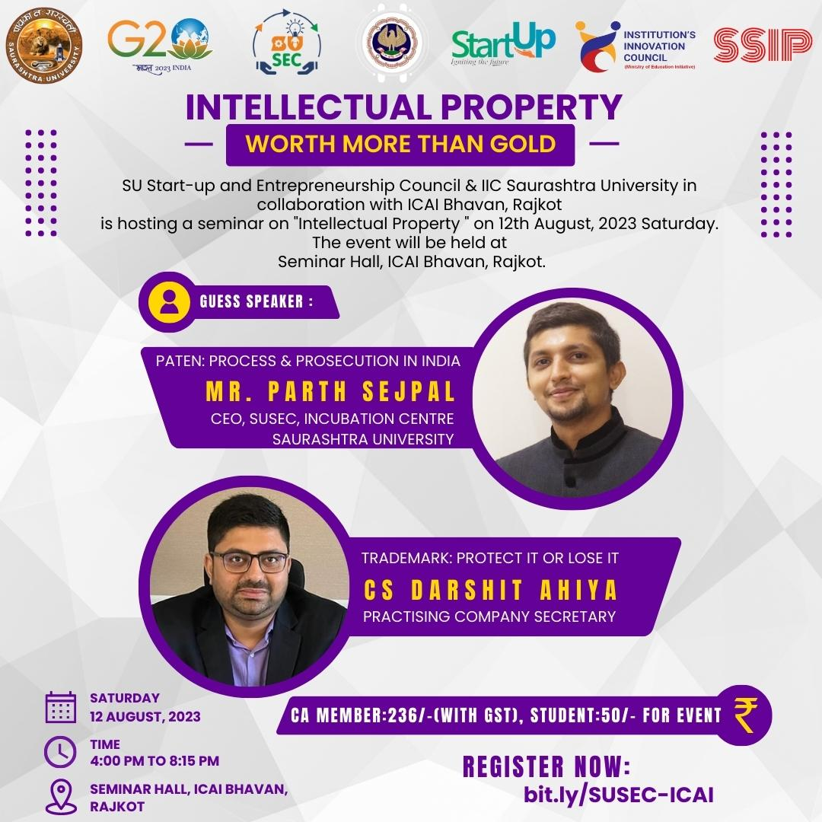

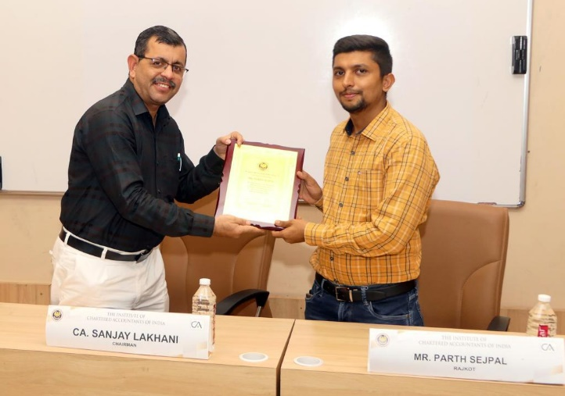
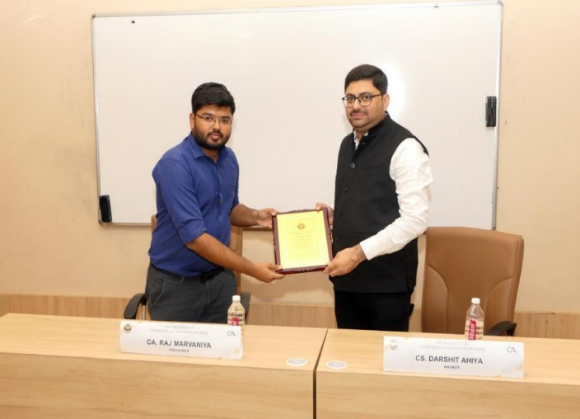

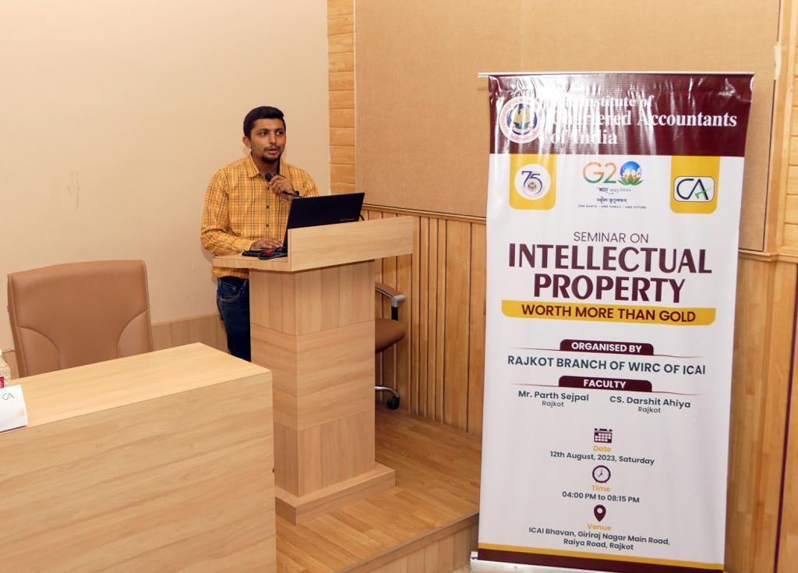

Connect Us:

https://www.linkedin.com/company/susec iic@sauuni.ac.in
https://www.facebook.com/iicsauuni https://bit.ly/SUSECLocation
https://www.instagram.com/susecrajkot https://bit.ly/SUSEC-youtube

